Федеральное агентство связи

Федеральное государственное бюджетное образовательное учреждение

высшего образования

«Сибирский государственный университет телекоммуникаций

и информатики»

Факультет мобильной радиосвязи и мультимедиа

Лабораторная работа

по дисциплине “Программирование для мобильных устройств”

Тема: «Калькулятор»

Выполнил: Студент группы ЗП-81

Фолов А.А.

Проверил: ___________________

___________________

Новосибирск, 2022

**Задание**

Реализуйте простейший Калькулятор. Имеется набор кнопок (цифр), (арифм. операций) и циферблат. Калькулятор позволяет вычислять (+,-,*,/) Предусмотреть обработку ситуации деления на ноль.

Пример:

Окно при запуске приложения.

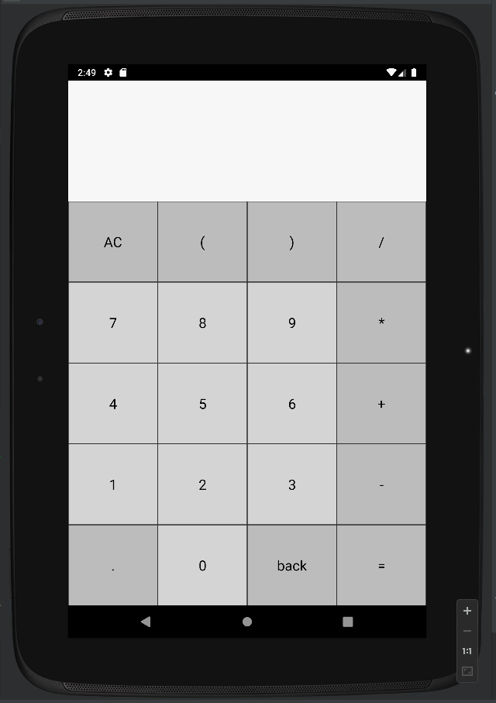

Сложная операция со скобками:

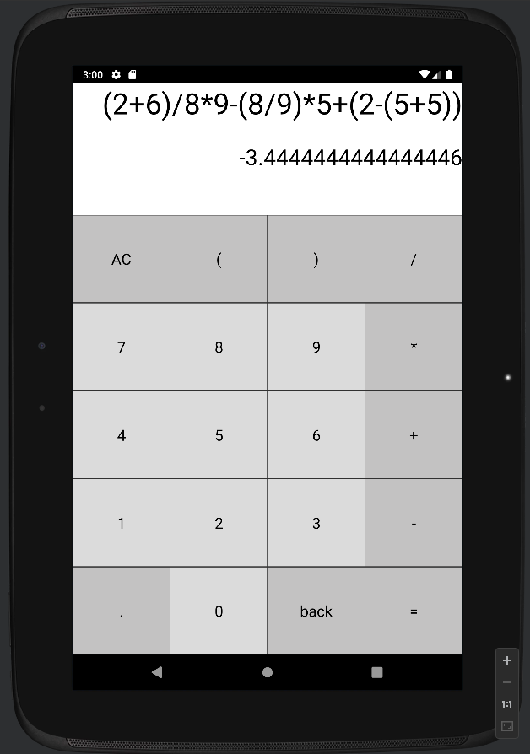

Умножение

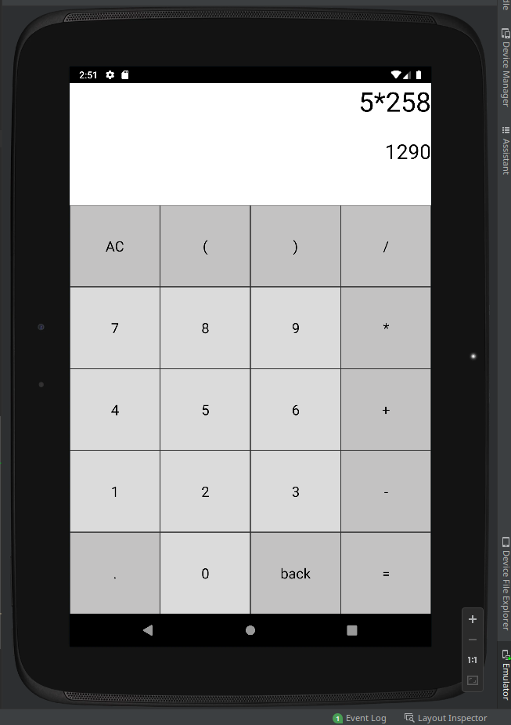

Деление

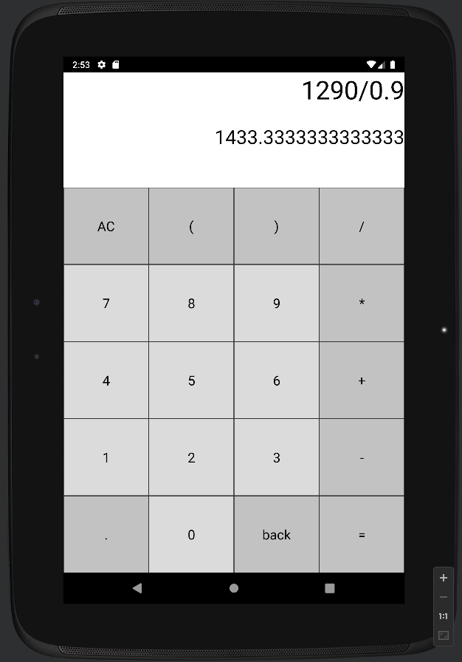

сложение

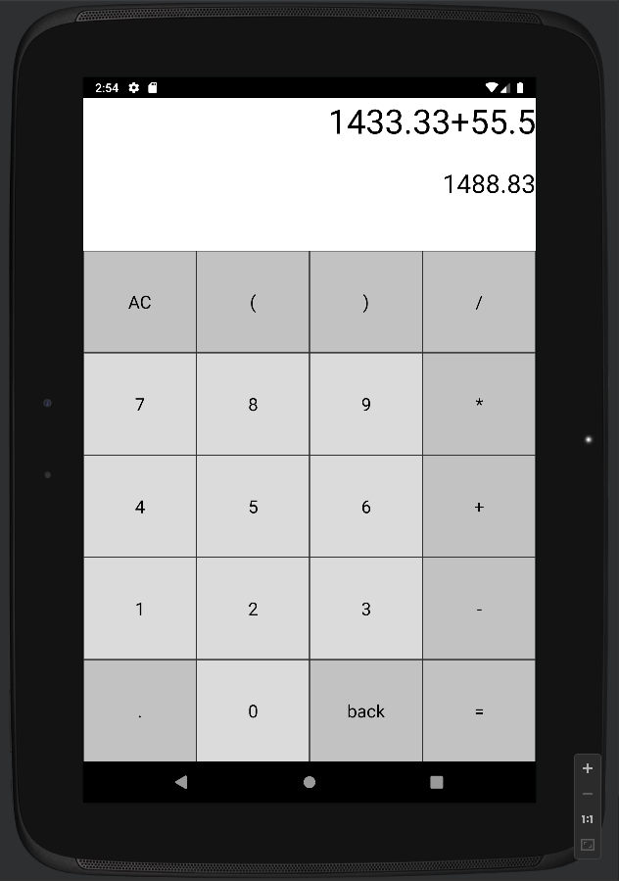

Вычитание

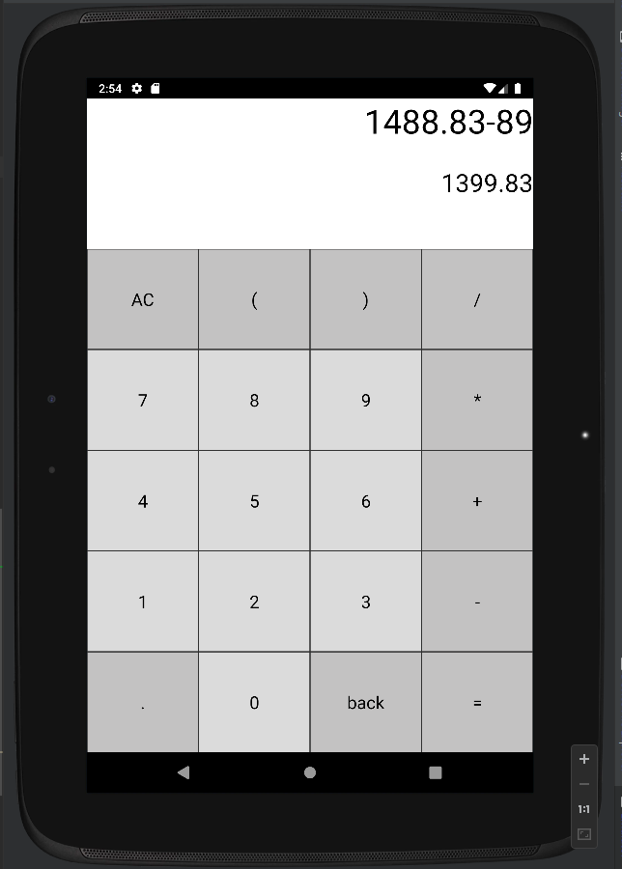

**Листинг**

**MainActivity.kt**

package com.example.calc  
  
import androidx.appcompat.app.AppCompatActivity  
import android.os.Bundle  
import android.widget.TextView  
import androidx.appcompat.app.AppCompatDelegate  
import net.objecthunter.exp4j.ExpressionBuilder  
import java.lang.Exception  
  
class MainActivity : AppCompatActivity() {  
  
 private lateinit var mathOperation: TextView  
 private lateinit var mathResult: TextView  
 private lateinit var btnAc: TextView  
 private lateinit var btnParenthesisStart: TextView  
 private lateinit var btnParenthesisEnd: TextView  
 private lateinit var btnDivide: TextView  
 private lateinit var btnMultiply: TextView  
 private lateinit var btnPlus: TextView  
 private lateinit var btnMinus: TextView  
 private lateinit var btnDot: TextView  
 private lateinit var btnBack: TextView  
 private lateinit var btnEquals: TextView  
  
 private lateinit var btnNum0: TextView  
 private lateinit var btnNum1: TextView  
 private lateinit var btnNum2: TextView  
 private lateinit var btnNum3: TextView  
 private lateinit var btnNum4: TextView  
 private lateinit var btnNum5: TextView  
 private lateinit var btnNum6: TextView  
 private lateinit var btnNum7: TextView  
 private lateinit var btnNum8: TextView  
 private lateinit var btnNum9: TextView  
  
  
 override fun onCreate(savedInstanceState: Bundle?) {  
 super.onCreate(savedInstanceState)  
 AppCompatDelegate.setDefaultNightMode(AppCompatDelegate.*MODE_NIGHT_FOLLOW_SYSTEM*)  
 setContentView(R.layout.*activity_main*)  
  
 mathOperation = findViewById(R.id.*math_operation*)  
 mathResult = findViewById(R.id.*math_result*)  
 btnAc = findViewById(R.id.*btn_ac*)  
 btnParenthesisStart = findViewById(R.id.*btn_parenthesis_start*)  
 btnParenthesisEnd = findViewById(R.id.*btn_parenthesis_end*)  
 btnDivide = findViewById(R.id.*btn_divide*)  
 btnMultiply = findViewById(R.id.*btn_multiply*)  
 btnPlus = findViewById(R.id.*btn_plus*)  
 btnMinus = findViewById(R.id.*btn_minus*)  
 btnDot = findViewById(R.id.*btn_dot*)  
 btnBack = findViewById(R.id.*btn_back*)  
 btnEquals = findViewById(R.id.*btn_equals*)  
  
 btnNum0 = findViewById(R.id.*btn_num_0*)  
 btnNum1 = findViewById(R.id.*btn_num_1*)  
 btnNum2 = findViewById(R.id.*btn_num_2*)  
 btnNum3 = findViewById(R.id.*btn_num_3*)  
 btnNum4 = findViewById(R.id.*btn_num_4*)  
 btnNum5 = findViewById(R.id.*btn_num_5*)  
 btnNum6 = findViewById(R.id.*btn_num_6*)  
 btnNum7 = findViewById(R.id.*btn_num_7*)  
 btnNum8 = findViewById(R.id.*btn_num_8*)  
 btnNum9 = findViewById(R.id.*btn_num_9*)  
  
  
 btnAc.setOnClickListener **{**  
mathOperation.*text* = ""  
 mathResult.*text* = ""  
 **}**  
btnParenthesisStart.setOnClickListener **{** setTextFields("(") **}**  
btnParenthesisEnd.setOnClickListener **{** setTextFields(")") **}**  
btnDivide.setOnClickListener **{** setTextFields("/") **}**  
btnMultiply.setOnClickListener **{** setTextFields("*") **}**  
btnPlus.setOnClickListener **{** setTextFields("+") **}**  
btnMinus.setOnClickListener **{** setTextFields("-") **}**  
btnDot.setOnClickListener **{** setTextFields(".") **}**  
btnBack.setOnClickListener **{**  
val str = mathOperation.*text*.toString()  
 if (str.*isNotEmpty*())  
 mathOperation.*text* = str.*substring*(0, str.length - 1)  
  
 mathResult.*text* = ""  
 **}**  
btnEquals.setOnClickListener **{**  
try {  
 if (mathOperation.*text*.toString() != "") {  
 val ex = ExpressionBuilder(mathOperation.*text*.toString()).build()  
  
 val result = ex.evaluate()  
  
 val longRes = result.toLong()  
 if (result == longRes.toDouble())  
 mathResult.*text* = longRes.toString()  
 else  
 mathResult.*text* = result.toString()  
 }  
 } catch (ex: Exception) {  
 mathResult.*text* = "Ошибка"  
 }  
 **}**  
  
btnNum0.setOnClickListener **{** setTextFields("0") **}**  
btnNum1.setOnClickListener **{** setTextFields("1") **}**  
btnNum2.setOnClickListener **{** setTextFields("2") **}**  
btnNum3.setOnClickListener **{** setTextFields("3") **}**  
btnNum4.setOnClickListener **{** setTextFields("4") **}**  
btnNum5.setOnClickListener **{** setTextFields("5") **}**  
btnNum6.setOnClickListener **{** setTextFields("6") **}**  
btnNum7.setOnClickListener **{** setTextFields("7") **}**  
btnNum8.setOnClickListener **{** setTextFields("8") **}**  
btnNum9.setOnClickListener **{** setTextFields("9") **}**  
}  
  
 fun setTextFields(str: String) {  
 if (mathResult.*text* == "Ошибка") {  
 mathOperation.*text* = ""  
 mathResult.*text* = ""  
 }  
 if (mathResult.*text* != "") {  
 mathOperation.*text* = mathResult.*text*  
mathResult.*text* = ""  
 }  
 mathOperation.append(str)  
 }  
}

**activity_main.xml**

<?xml version="1.0" encoding="utf-8"?><LinearLayout xmlns:android="http://schemas.android.com/apk/res/android" xmlns:tools="http://schemas.android.com/tools" android:layout_width="match_parent" android:layout_height="match_parent" android:orientation="vertical" tools:context=".MainActivity"> <TextView android:id="@+id/math_operation" style="@style/MathOperation" /> <TextView android:id="@+id/math_result" style="@style/MathOperation" android:layout_height="100sp" android:ellipsize="end" android:textSize="30sp" /> <LinearLayout android:layout_width="match_parent" android:layout_height="match_parent" android:orientation="vertical"> <LinearLayout android:layout_width="match_parent" android:layout_height="0dp" android:layout_weight="1" android:orientation="horizontal"> <TextView android:id="@+id/btn_ac" style="@style/ActionButton" android:text="AC" /> <TextView android:id="@+id/btn_parenthesis_start" style="@style/ActionButton" android:text="(" /> <TextView android:id="@+id/btn_parenthesis_end" style="@style/ActionButton" android:text=")" /> <TextView android:id="@+id/btn_divide" style="@style/ActionButton" android:text="/" /> </LinearLayout> <LinearLayout android:layout_width="match_parent" android:layout_height="0dp" android:layout_weight="1" android:orientation="horizontal"> <TextView android:id="@+id/btn_num_7" style="@style/NumberButton" android:text="7" /> <TextView android:id="@+id/btn_num_8" style="@style/NumberButton" android:text="8" /> <TextView android:id="@+id/btn_num_9" style="@style/NumberButton" android:text="9" /> <TextView android:id="@+id/btn_multiply" style="@style/ActionButton" android:text="*" /> </LinearLayout> <LinearLayout android:layout_width="match_parent" android:layout_height="0dp" android:layout_weight="1" android:orientation="horizontal"> <TextView android:id="@+id/btn_num_4" style="@style/NumberButton" android:text="4" /> <TextView android:id="@+id/btn_num_5" style="@style/NumberButton" android:text="5" /> <TextView android:id="@+id/btn_num_6" style="@style/NumberButton" android:text="6" /> <TextView android:id="@+id/btn_plus" style="@style/ActionButton" android:text="+" /> </LinearLayout> <LinearLayout android:layout_width="match_parent" android:layout_height="0dp" android:layout_weight="1" android:orientation="horizontal"> <TextView android:id="@+id/btn_num_1" style="@style/NumberButton" android:text="1" /> <TextView android:id="@+id/btn_num_2" style="@style/NumberButton" android:text="2" /> <TextView android:id="@+id/btn_num_3" style="@style/NumberButton" android:text="3" /> <TextView android:id="@+id/btn_minus" style="@style/ActionButton" android:text="-" /> </LinearLayout> <LinearLayout android:layout_width="match_parent" android:layout_height="0dp" android:layout_weight="1" android:orientation="horizontal"> <TextView android:id="@+id/btn_dot" style="@style/ActionButton" android:text="." /> <TextView android:id="@+id/btn_num_0" style="@style/NumberButton" android:text="0" /> <TextView android:id="@+id/btn_back" style="@style/ActionButton" android:text="back" /> <TextView android:id="@+id/btn_equals" style="@style/ActionButton" android:text="=" /> </LinearLayout> </LinearLayout></LinearLayout>

**themes.xml**

<resources xmlns:tools="http://schemas.android.com/tools"> <!-- Base application theme. --> <style name="Theme.Calc" parent="Theme.AppCompat.DayNight"> <!-- Primary brand color. --> <item name="colorPrimary">@color/purple_500</item> <item name="colorPrimaryVariant">@color/purple_700</item> <item name="colorOnPrimary">@color/white</item> <!-- Secondary brand color. --> <item name="colorSecondary">@color/teal_200</item> <item name="colorSecondaryVariant">@color/teal_700</item> <item name="colorOnSecondary">@color/black</item> <!-- Status bar color. --> <item name="android:statusBarColor" tools:targetApi="l">?attr/colorPrimaryVariant</item> <!-- Customize your theme here. --> </style> <style name="MathOperation"> <item name="android:background">#FFFFFF</item> <item name="android:layout_width">match_parent</item> <item name="android:layout_height">80sp</item> <item name="android:ellipsize">start</item> <item name="android:gravity">end</item> <item name="android:singleLine">true</item> <item name="android:textColor">@color/black</item> <item name="android:textSize">40sp</item> </style> <style name="ActionButton"> <item name="android:layout_width">0dp</item> <item name="android:layout_height">match_parent</item> <item name="android:layout_weight">1</item> <item name="android:background">#C3C2C2</item> <item name="android:textSize">21sp</item> <item name="android:textColor">#000000</item> <item name="android:gravity">center</item> <item name="android:layout_margin">0.5dp</item> </style> <style name="NumberButton"> <item name="android:layout_width">0dp</item> <item name="android:layout_height">match_parent</item> <item name="android:layout_weight">1</item> <item name="android:background">#DBDBDB</item> <item name="android:textSize">21sp</item> <item name="android:textColor">#000000</item> <item name="android:gravity">center</item> <item name="android:layout_margin">0.5dp</item> </style></resources>